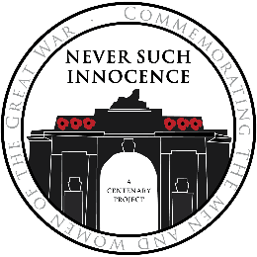

Together: A UK-German Centenary Project
Group Entry Form for UK

Please fill in your details below:
Name of Teacher
School / Group Name
Email address
Telephone
Postal address
Postcode
Please put an X in the appropriate box (Place X in ONE box only)
Category | Poetry Artwork
Are there any special educational needs you would like our judges to be aware of? If you wish, please give details. | No Yes

Please print names clearly
If you would prefer not to specify gender, please leave this blank
Full name of Entrant | Title of submission | School year / age | Gender M / F | Medium used (artwork only)

Deadline: Friday 27th July 2018 - to be in for the chance to have your work published in the Never Such Innocence Legacy Book you must submit your entry by Friday 15th June.
We regret that we are unable to return work due to the volume of entries that we receive. We accept photographs of artwork if you do not wish to send the original. Winners and runners-up will be notified on or before Friday 14th September 2018.
Postal entries must be titled and sent to:
Never Such Innocence
11 Slingsby Place
London
WC2E 9AB
Digitised entries must be submitted using our online form found on our website: www.neversuchinnocence.com
We are always looking to improve our outreach, so would be grateful if you could tell us how you found out about the competition:

The copyright of each entry remains with the author. However, authors of winning entries, by entering the competition, grant Never Such Innocence the right to publish and/or broadcast their work.
The information you provide to Never Such Innocence is safe with us and we do not sell your data to third parties. We will occasionally use your details for modelling and analysis purposes and to inform you of future projects we run.
We will use the information provided on this form to inform you of the outcome of the Together competition.
The ways in which we use your data will be in accordance with our Privacy Policy which can be found at https://www.neversuchinnocence.com/privacy-policy and we shall comply with our obligations in relation to your data and the General Data Protection Regulations (GDPR).
By entering into this competition, you are agreeing to share your data with us and that we can use your data as set out in our Privacy Policy. If at any time you would like to review or change the way in which we use your data, please contact us at enquries@neversuchinnocence.com

